
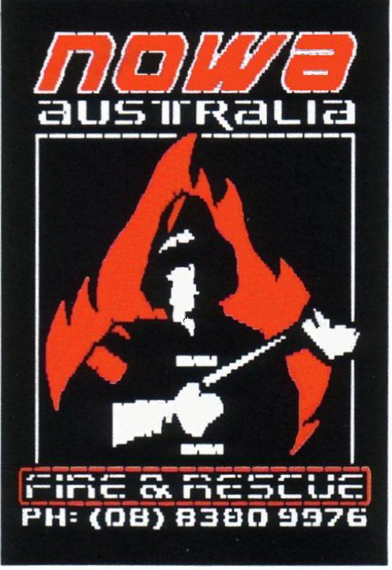

TM
Australian made and owned, 1% BUSHMASTER is completely bio-degradable and non-toxic. With 1% BUSHMASTER containing natural products, assists the regeneration of native flora after fires.
1% BUSHMASTER contains no PFOS, PFOA or formaldehyde. It contains only organic preservatives making it safe for fire fighters and the environment.
1% BUSHMASTER is a Faster Wetting, Deeper Penetrating with less evaporation and run off! These features help to save water, control bushfire attack more effectively. 1% BUSHMASTER is deeper penetrating into wood & materials, which wets faster than water alone.

1% BUSHMASTER - IT WORKS !
- Covers with a fluffy foam blanket to cut out the oxygen from the fire. (Depends on the water to foam ratio)
- Absorbs the heat from the fuel for more protection.
- Cools the fire by releasing encapsulated water from the foam to the fire.

1% BUSHMASTER - Use on Tyre Fires!
Alternative to using copious amounts of water and time, 1% BUSHMASTER is specially formulated as an ultimate wetting agent to penetrate the rubber where water alone just runs off. Using 1% BUSHMASTER brings safety with reduced fire fighting time and less environmental damage.

1% BUSHMASTER - Versatility
1% BUSHMASTER has a wide range of applications and use. Depending on the level of proportioning of 1% BUSHMASTER gives you a wide rage of uses from Asset Protection to Mop Up.
When added to water 1% BUSHMASTER can expand the volume of water up to ten times!

1% BUSHMASTER - Packaging
1% BUSHMASTER comes to you in easily identifiable pails with convenient colour coding and easy to read labeling, giving you the right product for the correct fire every time.
1% BUSHMASTER is available in 1Lt and 5lt bottles, 20Lt Pails, 200Lt Drums & 1000Lt Bulk Tanks.
1% BUSHMASTER - Application
With 1% BUSHMASTER you can simply add the concentrate to a tank of water or use conventional proportioning equipment, from in line injection / eduction to around the pump.
Rates of Application listed below;
- MOP UP 0.25%
- INITIAL 0.50%
- BACK BURN 0.75%
- PROTECTION 1.0%

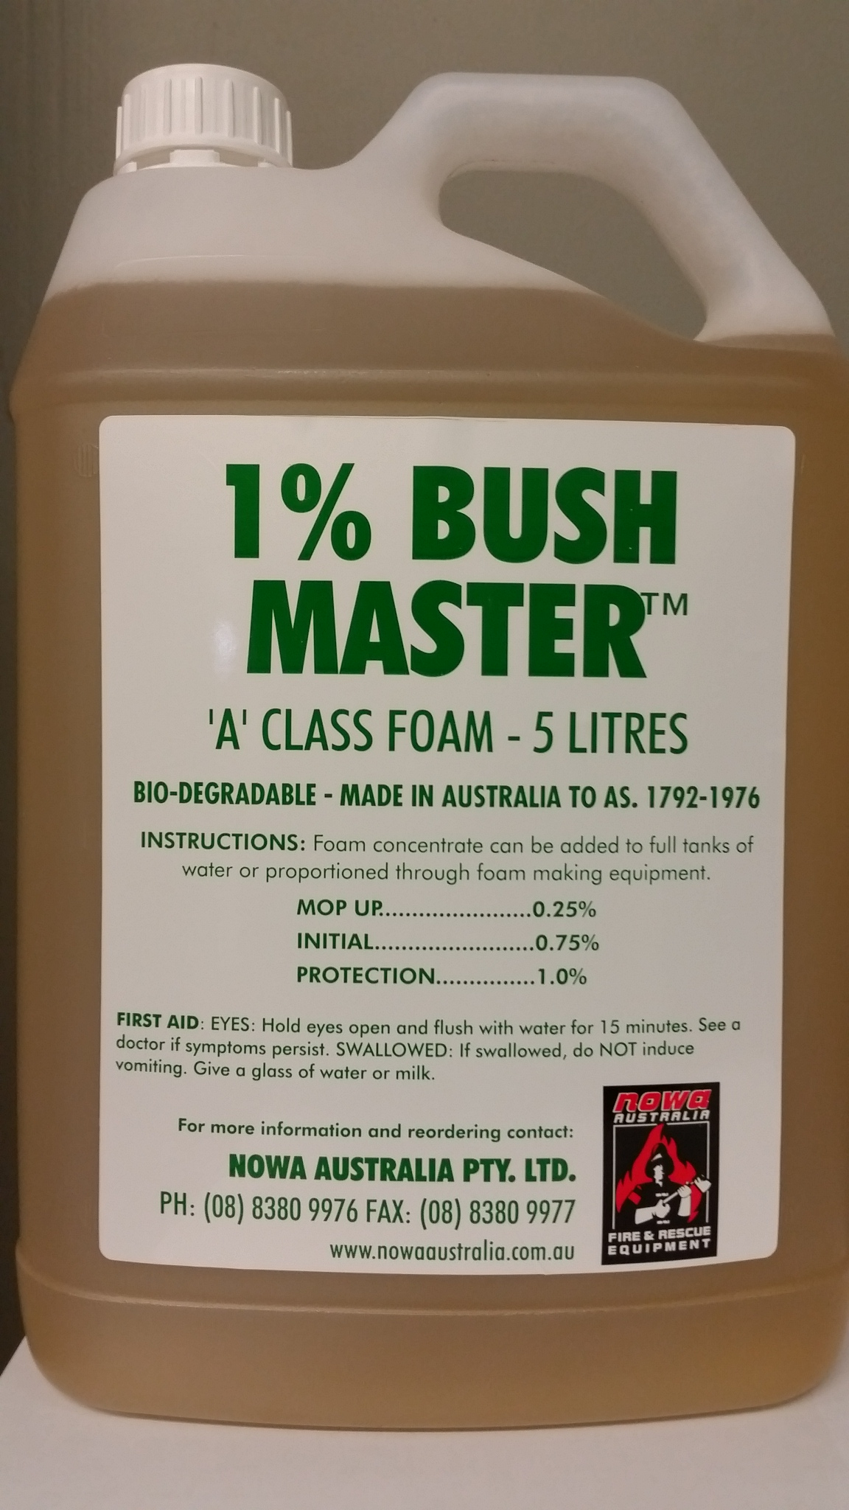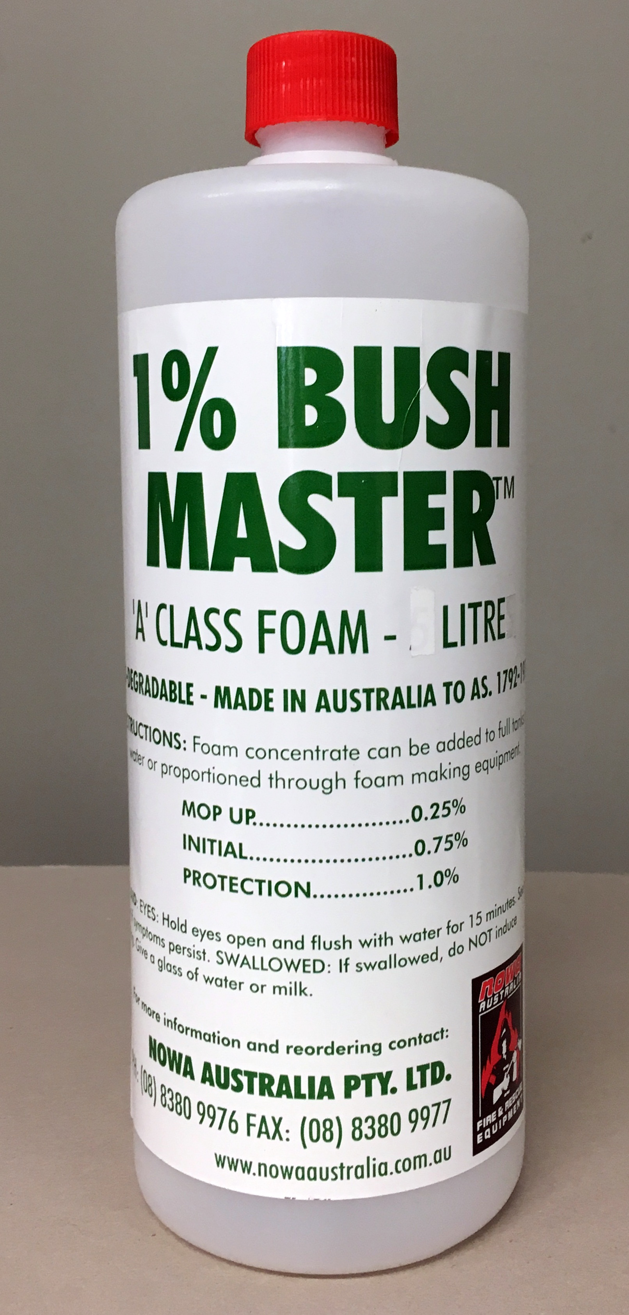

USDA Approved and NASAA Approved
MSDS available from NOWA Australia

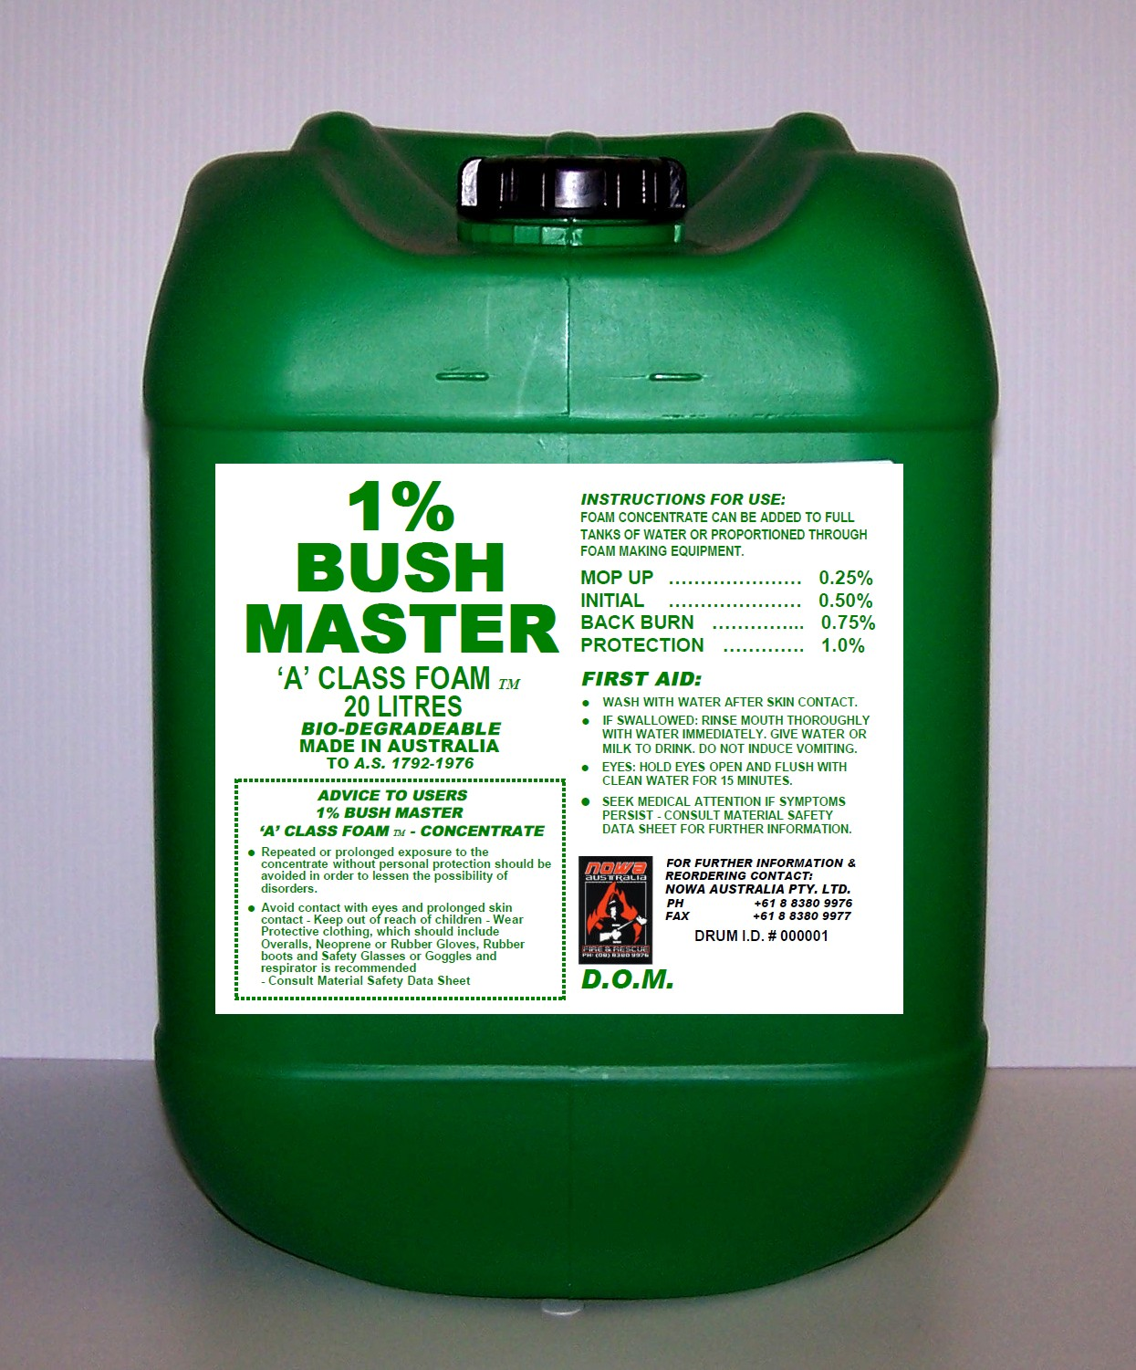

NOWA AUSTRALIA Pty Ltd
Ph: 08 8380 9976 – Fax: 08 8380 9977
Email: MDraganoff@aol.com
Web : www.nowaaustralia.com.au
44 BRADY Street, VIRGINIA
South Australia 5120

For more information and reordering contact:

